Manage Azure Storage

Lab Objective
In this lab, you learn how to:
- Create and secure an Azure Storage Account
- Store data using Azure Blob Storage and Azure File Shares
- Reduce storage cost using access tiers and lifecycle management
- Secure storage using network restrictions and SAS
- Understand replication and data protection mechanisms
This lab focuses on cost optimization, security, and access control for storage.

Business Scenario (Why This Lab Matters)
Your organization:
- Has on-premises data
- Rarely accesses most files
- Wants lower-cost cloud storage
- Needs secure access and replication
- Wants to test if Azure Files can replace file servers

Architecture diagram

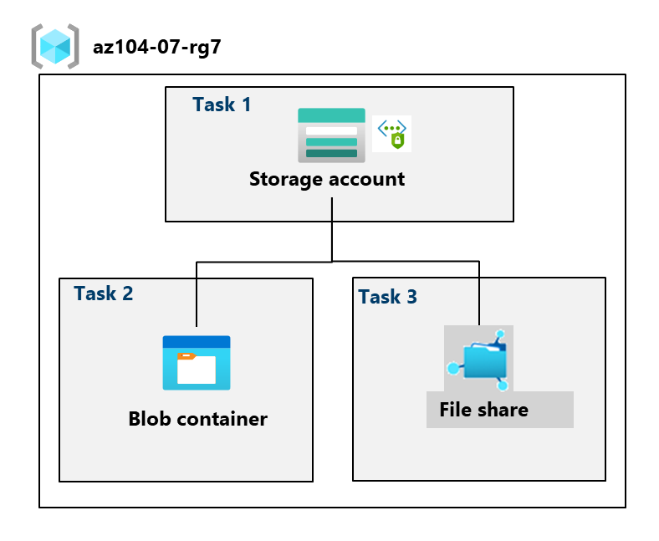

Task 1: Create and Configure a Storage Account

What is an Azure Storage Account?
An Azure Storage Account is a container for all Azure storage services, including:
- Blob storage
- File shares
- Queues
- Tables
It provides:
- A globally unique namespace
- Centralized security, networking, and replication settings

Key Configuration Concepts

1. Performance Tier
Tier | Use Case
Standard | Most workloads (cost-effective)
Premium | High IOPS and low latency workloads
✔ In this lab: Standard

2. Redundancy (Data Replication)
Geo-Redundant Storage (GRS):
- Data is replicated to:
  - Primary region
  - Secondary region (hundreds of miles away)
Read-Access GRS (RA-GRS):
- Allows read access from the secondary region during outages
✔ In this lab: GRS + Read access

3. Public Network Access
Controls who can access the storage account.
Options:
- Enabled from all networks
- Enabled from selected networks
- Disabled
✔ In this lab:
- Disabled initially
- Later enabled only for selected networks

4. Data Protection
- Soft delete: Recover deleted blobs (default: 7 days)
- Versioning: Keeps previous versions of blobs

5. Encryption
- All data encrypted at rest
- Microsoft-managed keys by default
- Supports customer-managed keys (CMK)

Lifecycle Management

What Is Lifecycle Management?
Automatically moves data between access tiers based on rules.

Access Tiers
Tier | Use Case
Hot | Frequently accessed data
Cool | Infrequently accessed data
Archive | Rarely accessed, long-term storage
✔ Rule created:
- If blob not modified for 30 days → move to Cool tier

Task 2: Create and Configure Secure Blob Storage

What is Azure Blob Storage?
Blob Storage is used for unstructured data, such as:
- Images
- Videos
- Documents
- Backups

Blob Containers
A container is a logical grouping of blobs.

Public Access Levels
Level | Description
Private | No anonymous access
Blob | Public read access to blobs only
Container | Public read access to container and blobs
✔ In this lab: Private

Immutable Blob Storage (WORM)

What Is Immutable Storage?
Write Once, Read Many (WORM) storage prevents:
- Modification
- Deletion

Policy Types
Policy | Description
Time-based retention | Locked for fixed duration
Legal hold | Locked until manually removed
✔ In this lab:
- Time-based retention
- 180 days

Blob Upload Settings Explained

Blob Type – Block Blob
- Best for:
  - Documents
  - Images
  - Media files

Access Tier – Hot
- Immediate access
- Higher storage cost, lower access cost

Why Direct Blob URL Access Fails
Because:
- Container is private
- Anonymous access is disabled
This is expected and secure behavior.

Shared Access Signature (SAS)

What Is SAS?
A SAS is a time-limited, permission-based access token.
Controls:
- Permissions (read, write, delete)
- Start and expiry time
- IP restrictions
✔ In this lab:
- Read-only access
- Valid for limited time

Task 3: Create and Configure Azure File Storage

What Is Azure Files?
Azure Files provides:
- Fully managed file shares
- Accessible via:
  - SMB
  - Azure Storage Browser
Used as:
- Replacement for on-prem file servers
- Shared storage for VMs

File Share Access Tiers
Tier | Use Case
Transaction optimized | General purpose
Hot | Frequently accessed
Cool | Infrequently accessed
✔ In this lab: Transaction optimized

